# Overview and Objectives

**Rationale:** Land-cover transformation, amplification of biogeochemical flows, and climate disruption are triggering transitions in the Earth system that are unprecedented on human timescales (Abbott et al. 2019; Steffen et al. 2018). Potential and ongoing ecosystem state changes threaten billions of individuals (Abatzoglou & Williams 2016; Dupas et al. 2019; Van Loon et al. 2016), highlighting the need to better understand the factors that determine ecosystem recovery or transition for a variety of disturbance types and in different contexts. **We hypothesize that critical zone (CZ) structure controls linkages among multiple responses to disturbance and thereby regulates ecosystem resilience and resistance to climate and land cover disturbance.** We predict that the capacity to identify and forecast ecological thresholds will be enhanced by jointly considering the multiple dimensions of ecosystem response. The CZ collaborative network is uniquely positioned to test this *multidimensional resilience hypothesis* because it enables interdisciplinary assessment of ecosystem states under a range of disturbance regimes across an array of CZ configurations in diverse socioecological contexts.

**Our cluster:** With our thematic cluster, we propose to **investigate ecological resilience and resistance by focusing on vulnerable systems experiencing overlapping disturbances** (e.g. drought, fires, heavy precipitation, and acidification) and which lie close to potential thresholds in water and energy balance (i.e. snow-dominated systems). CZ science has produced a wealth of insights on the connection between structure and function of Earth systems over the past decade (Banwart et al. 2011; Brantley 2014; Brantley et al. 2007; Chorover et al. 2017). However, the largely site-specific approach to CZ characterization has limitations, specifically if the scale of the problem transcends the bounds of a single observatory. To advance network-scale syntheses and to bring CZ science beyond single-watershed studies we will use adata-driven approach that combines bottom-up and top-down methods. Specifically, we will (1) compile existing ecohydrological data from across the US into a multidimensional CZ database, (2) perform advanced statistical analysis with complex systems tools to identify state changes in ecological function and ecosystem services, (3) refine hypotheses based on these data-driven approaches, and (4) perform in-depth process investigations at three focal sites that experienced overlapping disturbances in the northeast (NE) and southwest (SW). **To enhance the growth and inclusiveness of CZ and data science in underrepresented groups** **in STEM,** we will implement a comprehensive outreach program that will educate grade 7-12 teachers and train diverse participants in outdoor science at the undergraduate level.

**Our vision:** This work will generate new understanding of ecosystem function in the Anthropocene and empower the CZ community to transition into a phase of data-driven hypothesis generation and cross-site research (Abbott et al. 2016; Song et al. 2018; Zarnetske et al. 2018). **Our long-term vision for this network cluster is to become a resource for the CZ network and the broader science community** with respect to data access, data analysis tools, conceptual frameworks, and inclusive educational concepts. All of our approaches will be available for use by the network to enhance CZ science across the US, and we are committed to collaborating closely with the coordinating “HUB” to accomplish this growth.

**Intellectual merit:** For CZ science to reach its full potential, we need to advance our general understanding of how medium to large-scale ecological systems respond to change on multiple timescales. However, moving beyond descriptive study of individual catchments is a challenge due to the complex and variable surface and subsurface CZ characteristics that regulate nutrient, water, and energy balance. Until recently, characterizing these attributes at large spatiotemporal scales has been beyond the scope of typical 3 to 5-year projects awarded to individual field sites (Abbott et al. 2016; Kolbe et al. 2019). The availability of data from multiple observatories and monitoring networks at site to global scales (Shogren et al. 2019; Zarnetske et al. 2018), combined with techniques that can **harness the power of big data** (hereafter referred to as “complex systems tools”) (Bergen et al. 2019), creates an unprecedented opportunity to identify individual and interactive controls on ecosystem response to disturbance. This work could be transformative in its combination of statistical and process-based approaches to bridge scales and biomes, resulting in a more comprehensive and predictive model of the CZ.

# Scientific Theme and Conceptual Model

## CZ resilience and resistance: ecology concepts from a CZ lens

The CZ is commonly defined as the zone of life, spanning from the tops of the tree canopy down to the actively-cycled ground water (Fig. 1a; (Brantley et al. 2007; Chorover et al. 2007; Richter & Mobley 2009)). As a zone of active biotic and abiotic reactions, the CZ provides habitat for the Earth’s organisms and ecosystem services for human society (Amundson et al. 2007; Anderson et al. 2011; Anderson et al. 2008; Brantley et al. 2007; Chorover 2012; Perdrial et al. 2015). However, intensifying and overlapping disturbances could lead to *ecosystem state changes* (see Box 1 for definitions) that could impair CZ function and services required for societal well-being. **We hypothesize that CZ structure (i.e. configuration of biological, chemical, and physical characteristics) controls the timing, direction, and intensity of linkages among multiple responses and that these linkages regulate ecosystem resilience and resistance to climate and land cover disturbance.** This *multidimensional resilience hypothesis* can only now be tested thanks to the depth and spread of data available from CZ observatories (CZOs) and new data science tools.

Ecosystem vulnerability is inversely related to i) the rate and likelihood of an ecosystem returning to an initial state **after** a disturbance (*ecological resilience),* and ii) the ability of the ecosystem to remain in its initial state **during** a disturbance (*ecological resistance*). While these concepts have been discussed extensively and tested in many ecological contexts (Jiang et al. 2018; Turner et al. 2019), resilience and resistance are usually viewed as mono-dimensional properties—e.g. collapse in a biological population or breakdown in an atmospheric or oceanic current (Liu et al. 2019; Steffen et al. 2018)—rather than as a nested, interacting system that intrinsically depends on the structure and state of the CZ. We argue that when disturbance alters one dimension of ecosystem state, changes in that parameter may reshape the response function of other ecosystem dimensions, rendering them more or less resilient and resistant depending on CZ-mediated stabilizing or destabilizing feedbacks (Fig. 1).

***Box 1: Ecological Resilience Terminology***

*Ecosystem state:* A multidimensional parameter defined by conditions in the CZ (i.e. habitat), material and energy flow, and ecosystem services.

*State change:* Substantial shift in an ecosystem process or suite of processes. For example, change in vegetation type, loss of species, or change in streamflow-precipitation relationships.

*Threshold:* A point associated with a nonlinear response to a prolonged or punctuated disturbance. For example, collapse in an ecological community, acceleration of growth, or substantial change in nutrient retention following only an incremental change in external or internal forcing.

*Resilience:* Ability of an ecosystem to return to an initial state **after** a perturbation or disturbance.

*Resistance:* Ability of an ecosystem to remain in its initial state **during** a perturbation or disturbance.

*CZ attributes:* Biological, hydrological, geological, and human characteristics of the CZ.

*CZ structure:* Sum of CZ attributes plus their configuration, which can create emergent properties via stabilizing and destabilizing interactions.

Thresholds are points at which there is a substantial shift in sensitivity to external drivers, where prior to or immediately after the threshold the system is less or more sensitive to disturbance (Scheffer et al. 2012). Interactive thresholds can precipitate state changes where the CZ is restructured and functions may be lost. To understand future ecosystem response to disturbances, we must therefore characterize where singular thresholds occur and how CZ attributes may modulate the feedbacks among multidimensional thresholds (Fig. 1c).

## CZ structure **and coupled ecohydrological dynamics**

Water, carbon, and nutrient dynamics are particularly important in the context of *multidimensional CZ resilience* because they shape many aspects of the CZ and are affected by many of the Earth’s socioecological pressures (Keys et al. 2019; Steffen et al. 2018). Water is involved in all CZ processes, notably ecosystem productivity, respiration, and the transfer of dissolved and particulate material (Perdrial et al. 2018; Perdrial et al. 2014). Therefore, disturbances to the timing, quantity, and direction of water flow in the CZ lie at the center of the multidimensional CZ resilience framework. We are particularly interested in understanding how CZ structure interacts with climate and land-cover variability to change soil moisture, vegetation water stress, and nutrient flux by quantifying feedbacks that occur between vegetation recovery and water and nutrient budgets over longer timescales. Specifically, we ask:

* What CZ properties and climate characteristics regulate water, carbon, and nutrient retention?
* How do CZ properties, disturbance history, and land use affect resistance and resilience to more intense, large-scale disturbances under a changing climate and anthropogenic pressure?
* 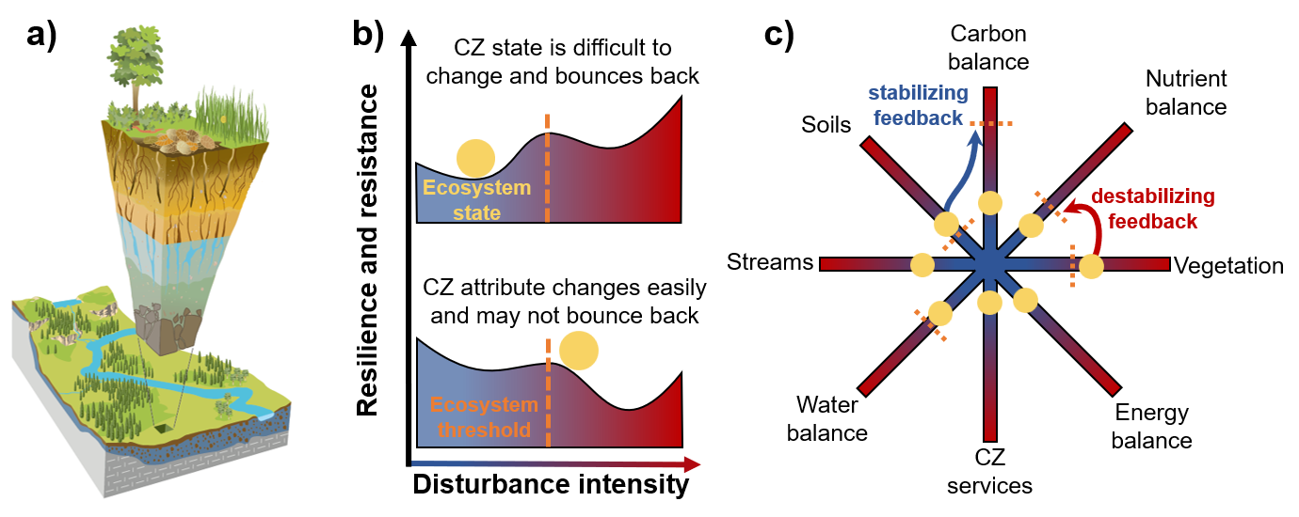How can we use multidimensional and multi-scale data on CZ structure to guide conservation and restoration interventions, and improve management outcomes with more predictive models?

Fig. 1. Conceptual diagram of CZ-mediated multidimensional resistance and resilience. a) The CZ extent from the top of the canopy to actively cycled groundwater. b) Ecosystem states, thresholds, and response surfaces representing likelihood of state change (upslope = resistant, downslope = nonresistant, valleys = ecological resilience) related to CZ attributes and structure. c) Top-down view of multiple dimensions of ecosystem state on their respective response surfaces, including feedbacks and thresholds. Exceeding a threshold in one dimension can modify or create a threshold in another, with thresholds near the center of the diagram representing more vulnerable dimensions.

Water budgets are fundamentally impacted by climate change, and even though effects vary geographically, several consistencies across snow-dominated systems have emerged. For example, 1. Rainfall intensity is likely increased at shorter time scales (Prein et al. 2017), 2. Evaporative water demand by the atmosphere is likely to increase (Holden et al. 2018), and 3. Increased energy will shift snow to rain and alter snowpack ablation patterns (Gleason et al. 2019). In this context, CZ structure fundamentally influences the partitioning of water and the resistance and resilience of water balance to climate and land cover change (Creed et al. 2014; Jaramillo & Destouni 2014; Maxwell et al. 2019). For example, CZ structure controls the three ways that water can leave a catchment (evaporation, transpiration, and lateral export via surface or groundwater flow) by controlling net energy budgets, energy required to remove water from subsurface porosity, rooting depth, nutrient availability, weathering depths, and net energy budgets, with multiple feedbacks among these properties (Fig. 2).Indeed, the attributes and structure of the CZ contribute as much or more of the uncertainty in projections of water and energy balance than external drivers from climate (Laizé et al. 2014).

The availability of water fundamentally controls carbon and nutrient cycles with far-reaching consequences. Water and energy availability determines net ecosystem carbon budgets by controlling both retention as well as lateral and vertical exchange (Öquist et al. 2014; Perdrial et al. 2018). These nutrient export regimes are partially regulated by state variables such as streamflow, soil moisture, and vegetation growth, all of which are themselves impacted by CZ structure (Fig. 2), e.g. via biological nutrient uptake or sorption on geomedia (Dupas et al. 2019; Perdrial et al. 2015). The complex and coupled linkages among water delivery, nutrient dynamics, and disturbances at specific locations can diminish the capacity of the CZ to retain and effectively cycle carbon and nutrients, which results in the export of powerful greenhouse gases (CO2, CH4, N2O (Cole et al. 2007; IPCC 2013; Seneviratne et al. 2012)), and aqueous species that promote water browning (dissolved organic carbon; DOC) or cause eutrophication (inorganic nutrients) (Abbott et al. 2014; Rosemond et al. 2015; Song et al. 2018; Yan et al. 2016).

## Examples of CZ - Mediated Resilience in the US

Resilience only becomes visible when a system is perturbed. We therefore focus on vulnerable systems that lie close to thresholds in water and energy balance (i.e. snow-dominated systems) and that experience overlapping disturbances, such as drought and fires in the southwest (SW), or acidification and extreme precipitation in the northeast (NE).

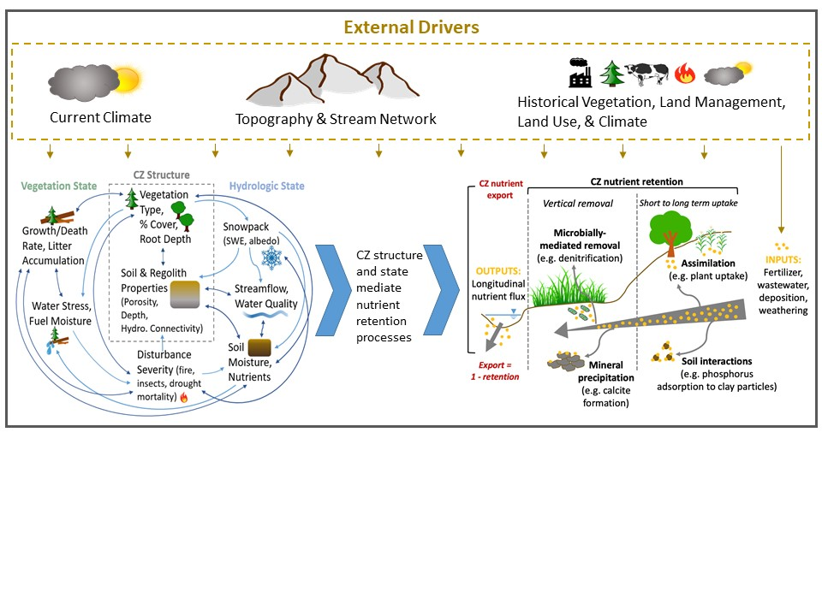

Fig. 2. Conceptual model of how external drivers mediate interconnected ecohydrological processes. The lower right section gives a more detailed illustration of how various interacting processes (arrows in the left figure) combine to affect the state of nutrients in the CZ.

The entire NE US has experienced a prolonged disturbance in the form of dramatic shifts in the chemical composition of precipitation, first due to acid deposition through much of the 20th century (Rice & Herman 2012), then through its reversal after the passage of the Clean Air Act in 1990 (Armfield et al. 2019; Futter et al. 2014). Concurrent with the recovery from acidification, changes to the climate system have led to increasing precipitation, which is amplified by increasing frequency of extreme hydrological events such as heavy precipitation (Arnone et al. 2011; Campbell et al. 2009; Jentsch et al. 2007; Seneviratne et al. 2012). The effects of these overlapping disturbances have produced DOC export patterns that are difficult to interpret and are hence debated extensively (De Wit et al. 2007; Eimers et al. 2008; Evans & Monteith 2001; Freeman et al. 2001; Hruška et al. 2009; Lepistö et al. 2008; Monteith et al. 2007; Worrall & Burt 2007). Punctuated disturbances (such as heavy precipitation or ice storms) are superimposed on these prolonged trends and can alter catchment carbon and nutrient fluxes for years (Cannell & Morgan 1989; Irland 2000; Smith 2000; Underwood 2017). While vegetation and biotic responses to acidification recovery may be positive and suggest resilience to these prolonged disturbances, the effects on water quality resilience may be more complex and understanding differential responses of biotic uptake, carbon, and nutrient retention to these interacting disturbances remains a critical challenge**.** CZ structure can mitigate effects of such multiple disturbances and explain observed variability in resilience. For example, the presence of carbonate bedrock can buffer deposited acids in soils (Armfield et al. 2019; Shanley et al. 2004; Shanley et al. 2015).Thick soils and wetlands can retain carbon and remove nutrients, while steep slopes increase erosion and diminish the CZ’s capacity to retain carbon and nutrients.

In contrast to the NE, the montane forested CZ in the SW US experiences increasing droughts that are punctuated by repeated fire and exhibits striking examples of resilience and resistance. In this case, decades of fire suppression have left montane forests at high risk of catastrophic fire. This problem is again exacerbated by changes to the climate system. Fires can alter nutrient loads by volatilizing nitrogen (Baird et al. 1999), causing increased erosion (and thus increased stream turbidity), and/or altering the vegetation composition which uses and fixes nutrients. Repeated wildfires have been shown to lead to an overall reduction in carbon loads, while making the remaining carbon more stable and resilient since the forest is less prone to severe fire removing large proportions of the stored carbon in one event (North & Hurteau 2011). Furthermore, droughts can alter the nutrient balance through a reduction in streamflow export and vegetative uptake (Liu et al. 2019; Stovall et al. 2019). The details of all these processes are highly context-dependent, and little field-based study has been done in areas experiencing frequent wildfires.

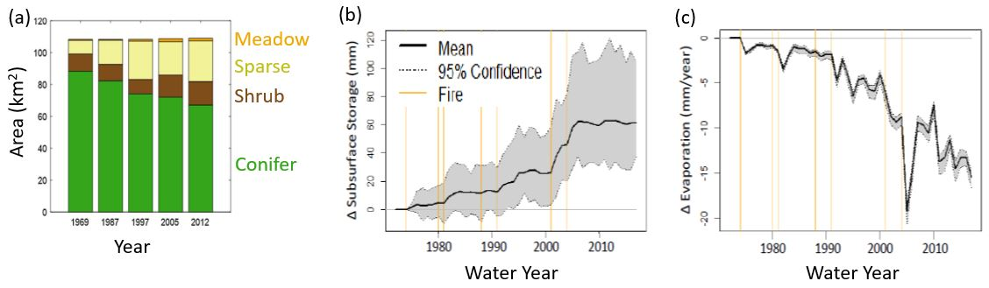CZ structure such as local soil depth and topography (e.g. slope, aspect, contributing area) can influence resilience to prolonged drought and punctuated fire disturbance. For example, research in the Illilouette Creek Basin (ICB) in Yosemite National Park showed that response to changes in fire-suppression practices varied spatially due to variations in CZ properties (Boisramé et al. 2017a; Boisramé et al. 2019). Heterogeneous CZ structure and function in the watershed allowed landscape diversity in vegetation and hydrologic terms to increase when fire was reintroduced to the landscape; this diversity may have increased basin-wide resilience to drought and fire (Boisramé et al. 2017a; Boisramé et al. 2017b). Even though landscape patterns continued to change with repeated fires, after ~25 years without fire suppression the overall distribution of vegetation types varied about a new fixed mean that was different from the fire-suppressed period (Fig. 3a;(Boisramé et al. 2017b)). Some hydrologic properties appeared to level out at a new state much as vegetation did (Fig. 3b) while others were still in flux (Fig. 3c), demonstrating the complexity of tracking multidimensional resilience. Certain hydrologic responses to the vegetation changes were highly dependent on the model parameterization of CZ subsurface properties (Fig. 3b; (Boisramé et al. 2019)).

Fig. 3. (a) Total area covered by each vegetation class in different years in ICB, based on aerial imagery. Rates of change decrease in the later years, suggesting vegetation distribution is converging around a new stable state. (b) Difference in subsurface water storage between a fire and fire-suppression scenario, year of a large fire indicated by yellow vertical lines. (c) Evaporation has not reached a new stable state, showing an example of attributes responding differently to disturbance.

# **Integrated Observations and Modeling Approach**

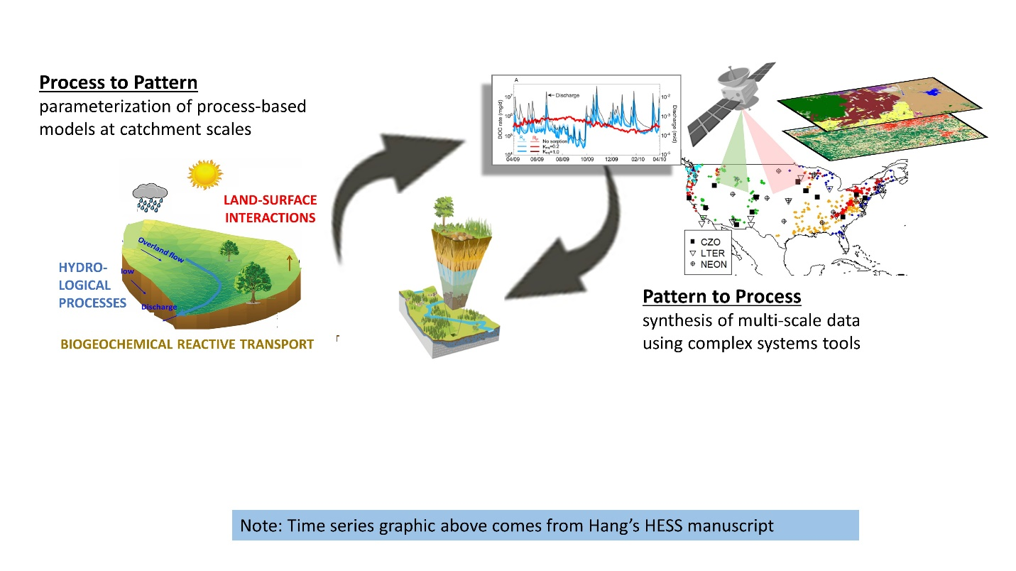To test the *multidimensional CZ resilience hypothesis*, our investigative framework will merge top-down and bottom-up approaches to integrate observations and models across scales (Fig. 4). Data-driven approaches using complex-systems tools will extract patterns, seek emergent phenomena, and identify key drivers of resilience from high-spatial-resolution observations at the continental scale (e.g., CZO, LTER, NEON), as well as high spatiotemporal-resolution observations at the catchment scale. In turn, these data will support statistical and mechanistic models implemented at key focal sites to generate insights on the nonlinear coupling and feedbacks among multiple competing processes operating at the catchment scale.

Fig. 4. Integration of top-down, and bottom-up investigative approaches.

Such hybrid investigative frameworks have been called for in Earth system sciences (Bergen et al. 2019; Larsen 2014; Reichstein et al. 2019) as a way to transcend the limitations of single-watershed studies and advance the synthesis of CZ phenomena and processes across watersheds and ecoregions at a larger scale.

## Pattern to Process: Complex-Systems Tools to Harness the big data revolution across scales

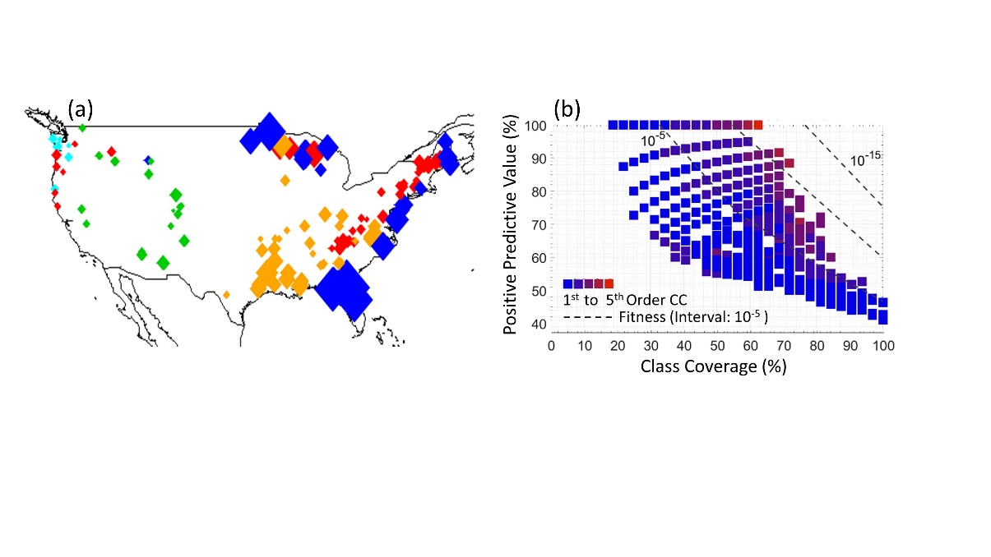With the advent of new technology such as sensors and light detection and ranging (lidar), we are amassing high volumes and wide variety of observational data (Demchenko 2013) that can be used to test hypotheses on ecosystem response or resilience to disturbance regimes and associated CZ water, carbon, and nutrient dynamics. This big data revolution has had a transformative impact across virtually all disciplines (Alexander et al. 2015; Li et al. 2012) and is poised to transform CZ sciences as well (Reichstein et al. 2019). The recent emergence of new statistical and machine-learning algorithms has been driven, in part, by the advances in distributed computing and storage that accompany long-term monitoring, but more importantly, by the challenges in mining and analyzing these large, multi-scale, data-rich complex-systems. Collectively, complex-systems tools comprise a variety of approaches including machine-learning algorithms, nonparametric statistics, network analysis, Bayesian inference, stochastic models, and evolutionary computation, and can be used for classification, regression, and prediction tasks in the analysis of CZ dynamics at scales ranging from large to fine in both a temporal and spatial context.

Fig. 5. (a) Five clusters of (n=451) HCDN sites were defined by an unsupervised, Hierarchical Agglomerative Clustering algorithm. Colors denote unique cluster assignments for n=133 sites with available DOC data. Symbol size is graduated by square root of DOC concentration. (b) A supervised evolutionary algorithm identified multivariate combinations of catchment attributes (i.e., conjunctive clauses) that predicted membership in the cluster with highest mean DOC (colored blue in Fig. 5a).

We can apply complex-systems tools to draw inferences from both terrestrial and aquatic signals of high temporal and spatial resolution (e.g., lidar first returns, time series of rainfall-runoff patterns or concentration discharge monitoring data) that serve as integrators of CZ dynamics, and have the potential to reflect the large-scale impacts of disturbances on the CZ as a whole. For example, machine-learning algorithms are increasingly being used to learn patterns from data and CZ science for both clustering (i.e., unsupervised) and classification (i.e., supervised) tasks (Bergen et al. 2019). Unsupervised neural networks such as Self-Organizing Maps have been used to cluster catchments with similar combinations of multi-variate catchment attributes (Underwood 2017), Supervised methods, including nearest-neighbor and ‘random forests’ imputation methods, have been applied to model forest structural parameters including biomass and total timber volume using predictor variables generated from lidar data or orthoimagery (Latifi et al. 2010). Supervised methods are especially useful for cases such as this where manual classification would be too time-intensive, but can also be used to learn something about the multivariate feature interactions that manifest in an outward class or condition. For example, the PIs have applied an age-layered evolutionary algorithm (Hanley 2019; Hanley 2016) to evolve probabilistically-significant, multivariate feature interactions linked to geographic clusters of USGS Hydro-Climatic Data Network sites (Underwood et al. 2019). Multivariate interactions are represented as conjunctive clauses with high probability to be linked to an output class (e.g., high DOC concentration). This algorithm shows high promise for identifying heterogeneity in large data sets, where different combinations of multiple features independently predict the same output class (Fig. 5b).

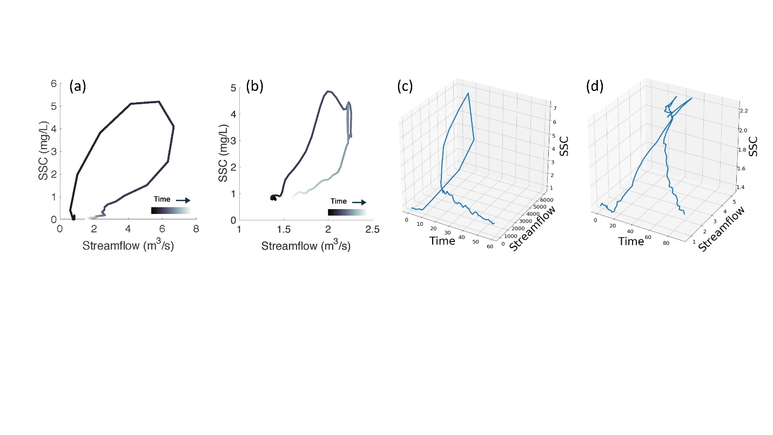However, machine-learning approaches have yet to be widely applied to combined spatiotemporal dynamics of the CZ such as fire dynamics or changing vegetation patterns in response to prolonged or punctuated disturbances (Reichstein et al. 2019). The present state of an ecosystem is, in part, a function of past state variables and external forcing conditions (Fig. 2). These memory or lag effects can influence predictions of future ecosystem states. For example, flood magnitude and hydrograph time-to-peak are, in part, a function of antecedent soil moisture conditions and the height of the groundwater table. The rate and extent of fire propagation will be influenced by fuel availability (i.e., wood), antecedent moisture condition of that fuel, and the degree of spatial connection of fuel stores.

*Fig. 6. (Suspended sediment concentration (SSC) vs stream discharge hysteresis loops for two hydrological events (a and b) categorize as a clockwise loop under the 5-class system of Williams ((1989)), but are placed in different classes when projected as spatiotemporal trajectories and classified by a recurrent neural network (c and d). Note the difference in rate of change along the two loops.*

A new subset of machine-learning algorithms, namely ‘deep learning’, show promise for advances in classification, anomaly detection, regression and prediction, where state variables are dependent on a spatial and/or temporal context (Reichstein et al. 2019). For example, three-dimensional convolutional neural networks have enhanced lidar-based forest inventories by spatially resolving individual tree crowns and distinguishing needle-leaf trees from deciduous ((Ayrey & Hayes 2018). They also been used to increase classification accuracy of storm-event hysteresis images (Hamshaw 2019). Concentration-discharge hysteresis loops can be projected in 3D as a spatiotemporal trajectory to include the temporal context (Fig. 6).

The PIs have recently applied a partitional clustering method (K-medoids with Dynamic Time Warping) and a recurrent neural network with long-short-term-memory (RNN-LSTM) to cluster spatiotemporal trajectories for 765 storm events. Notably, classes derived from analysis of these 3D spatiotemporal trajectories had greater explanatory power than classes generated through analysis of the 2D hysteresis loops when compared to 24 topographic and hydrologic metrics commonly used as explanatory variables for storm-event classes.

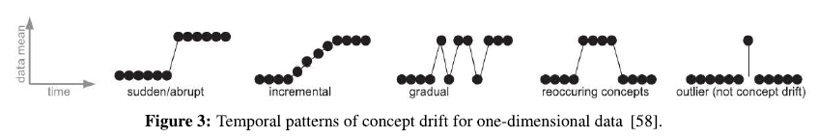Most importantly, new approaches combining spatial (convolutional) learning with sequence (recurrent) learning are needed (Reichstein et al. 2019) to address the complex spatiotemporal dynamics of the CZ in response to multidimensional disturbance. “Concept drift” is a term used in machine-learning to describe a change in the distribution of events monitored over a data stream. Concept drift detection considers: (1) what changes should be detected, (2) how to detect them, (3) how to update the conceptual model to reflect the changes, and (4) how long the changes should be “remembered” or when they may be “forgotten”. Changes may show different behaviors (e.g., Fig. 7); we expect to observe similar patterns when applying concept-drift detection to distributions of hydrological event classes or vegetative event classes to assess ecosystem resilience mediated by CZ structure using a suite of integrated field and remotely sensed data.

Fig. 7. Temporal patterns of concept drift for one-dimensional data.

Detecting concept drift is important for updating predictive models of system behavior, and the time detection of such drifts is important in responding to a causal disturbance. In this research, we propose new ecohydrological applications of concept drift detection, in which “concept” could be defined as the distribution of (categorical) event-scale hysteresis classes observed in individual catchments, or a cluster of similar catchments. Similarly, concept drift could be defined as a shift in the vegetative state of a catchment over time.

## Process to Pattern: Mechanistic models to test multidimensional resilience hypotheses at the catchment scale.

Extracting patterns at continental and regional scales will lead to the generation of more process-based hypotheses that can be tested at the CZ catchment scale. Process-based model development in the hydrology and biogeochemistry communities has largely taken parallel routes. Hydrologists have long developed distributed models to simulate hydrological processes at the watershed scale, while typically not taking into account reaction processes (Abbott et al. 1979; Gan et al. 2006; James 1972; Jarboe & Haan 1974; McDonnell et al. 2007; VanderKwaak & Loague 2001). In contrast, reactive transport models have been developed for decades in subsurface biogeochemistry; however, they rarely interface with surface hydrology and surface-groundwater interaction processes (MacQuarrie & Mayer 2005; Steefel et al. 2005). Spatially explicit models across hydrology and biogeochemistry communities have only recently begun to emerge (Bao et al. 2017; Li 2019; Yeh et al. 2006). Collaborator Li’s group has recently developed BioRT-Flux-PIHM (hereafter BFP) that enables the simulation of coupled land-surface interactions, hydrological and biogeochemical processes that ultimately control solute export (Bao et al. 2017; Wen et al. 2019) (Bao et al. 2016). BFP has enabled resolving the long-standing puzzle of chemostasis in hydrogeochemistry, i.e., the relatively small concentration variation compared to orders of magnitude variations in discharge for geogenic species (Na, Si, Ca, and Mg) in forest catchments (Clow & Mast 2010; Godsey et al. 2009), suggesting that chemostasis arises from synchronized responses of mineral dissolution rates (releasing geogenic species) and water storage corresponding to changing surface hydrological conditions. This has challenged previous thought that soil buffering capacity/equilibrium determines stream water solute fluxes (Clow & Mast 2010; Maher 2011). Recent work using the code in Shale Hills also suggests that catchments serve as a DOC producer in the hot, dry summer while a DOC exporter in the cold, wet winter, accentuating the asynchrony in microbe-mediated solute production versus water-mediated export (Wen et al. 2019). In the proposed work, soil-carbon-nutrient-water interactions will be represented in the reaction network integrating physical and geochemical characteristics of soil aggregates. These soil processes will be coupled with watershed hydrological dynamics to enable predictive understanding of carbon and nutrient export, as well as identifying key processes and emergent behavior.

To test hypotheses on climate-vegetation-hydrology-soil-nutrient interactions, we will use the Regional Hydro-Ecological Simulation System (RHESSys) model. This distributed, process-based model simulates water fluxes, vegetation dynamics, snowpack dynamics, and nutrient cycling (C and N only) at the vegetation-patch scale (Tague & Band 2004). Within the modeled watershed, lateral surface and saturated subsurface water redistribution between spatially-explicit patches are based on surface topography and calibrated drainage parameters. RHESSys is well suited to capturing the interactions between disturbance and CZ structure since it can simulate dynamic vegetation responses and includes explicit representation of both vegetation and subsurface structure. It has previously been used to study hydrologic responses to land cover and/or climate change in a variety of applications (Boisramé et al. 2019), including the example shown in Fig. 3b-c.

# **Our network cluster: advancing CZ science, engaging the CZ community and educating a diverse workforce**

With our cluster we will test hypotheses on the role that CZ structure plays in controlling responses to overlapping prolonged and punctuated disturbance in the framework of multi-dimensional resilience. Our cluster consists of ten core researchers that span a wide variety of CZ disciplines (geology, mineralogy, hydrology, ecology, geomorphology, biogeochemistry) and data science fields and have demonstrated expertise in the type of convergent research we propose (Fig. 8). Half of our team already collaborates on a project that uses complex-systems tools and process-based approaches to bridge scales in CZ science (see results from previous support). Furthermore, we will enhance CZ and data science education to fully engage underrepresented groups in STEM with our education program. Our team also represents diversity in STEM: 80% of our team identifies as underrepresented in STEM and 50% of our team are early career scientists. We will recruit several postdoctoral researchers, graduate and undergraduate students, as well a part time support staff, and actively bring in members of the larger community. To accomplish this work we have established a clear structure for responsibilities, collaboration, and the support for early-career scientists on the team (see management plan). To serve as a community resource we will collabo­rate closely with the HUB, and specific key person­nel will have dedicated roles in interacting with the HUB on 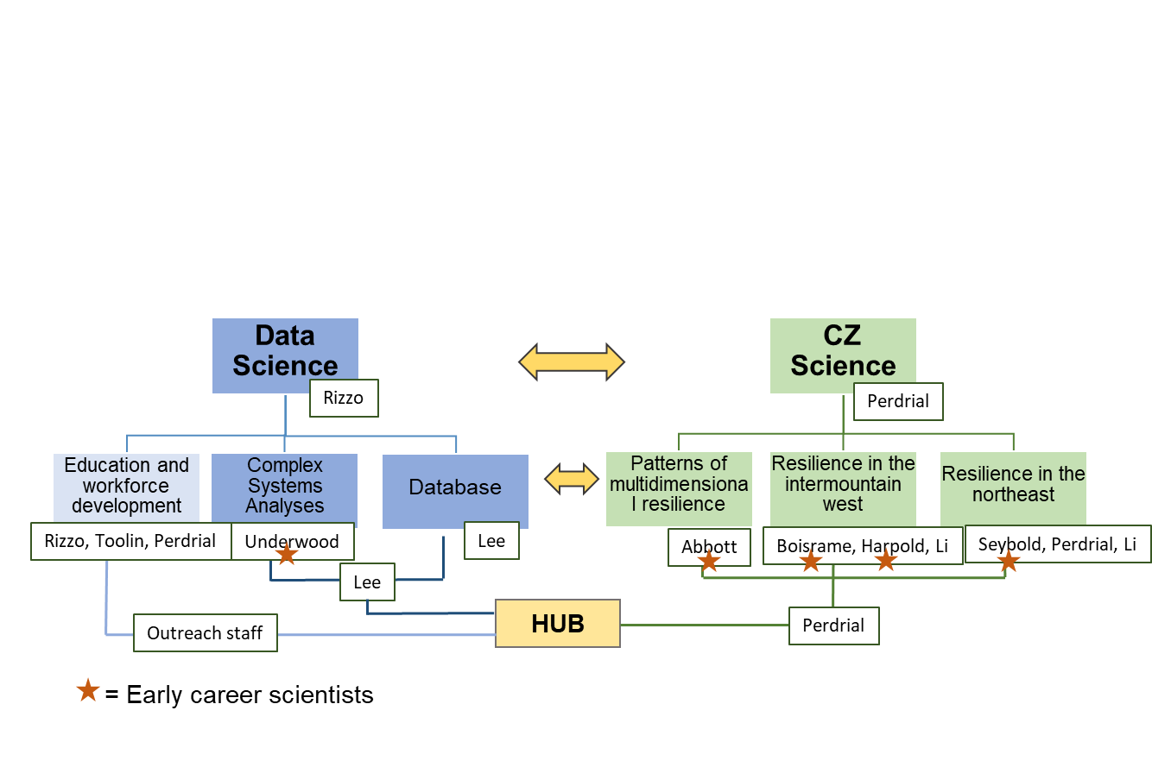education, data management and analyses, and CZ science questions.

Fig. 8. Organizational structure of the big data CZ network cluster.

## **Participating sites**

We have carefully selected three sites from snow-dominated areas of the US that occupy regions of contrasting catchment attributes, and have a long-term and/or detailed record of past disturbances for testing of our *multidimensional CZ resilience* hypothesis (Fig. 9). We will support the continued collection of environmental data at these sites to probe process hypotheses using statistical and mechanistic models. A fourthsite will complement the NE regional study and will be selected based on results of our complex-systems analyses of relevant CZ attributes after year 1.

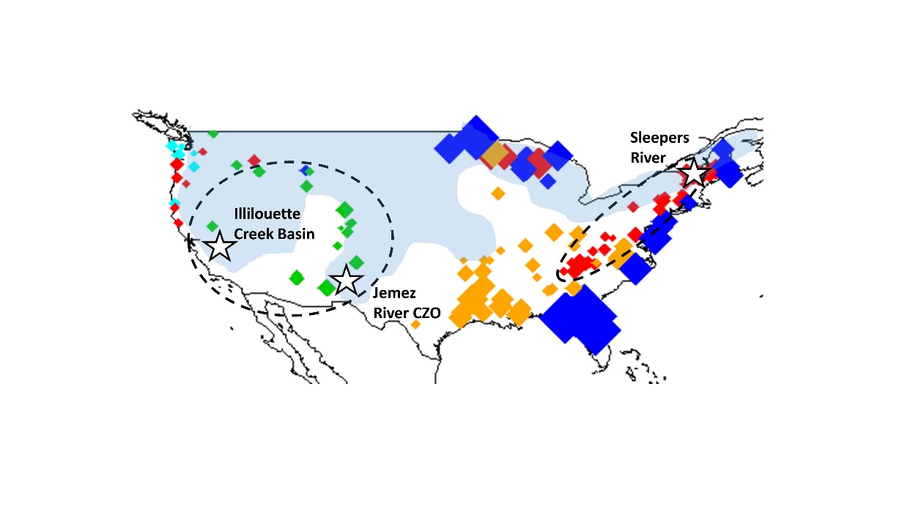1) **The Sleepers River Research Watershed (SRRW)** in northeastern Vermont is an ideal testbed for in-depth, process-based analyses quantifying the effects of overlapping disturbances (acidification and extreme precipitation) in the NE and we have existing expertise and collaborations (Armfield et al. 2019; Cincotta et al. in press). This forested watershed experienced strong acidification via wet and dry deposition, but carbonates in the glacial till buffer the pH, which allows us to investigate the effect of changes in precipitation patterns more clearly. Elevation ranges from 524 to 672 m above sea level (a.s.l.) and mean annual precipitation is ~ 1100 mm, of which ~ 23% falls as snow. Existing data sets include decades of records on the composition of soil, groundwater, stream water and soil chemistry at various landscape positions from archived and modern samples. Instrumentation includes a nested system of gaged streams, instream fluorescence and turbidity sensors, as well as met stations.

Fig. 9. Focal sites selected from two snow-dominated (blue shading), montane regions of the US with contrasting catchment attributes: Northeast (red cluster) and Southwest (green cluster).

**2) The Illilouette Creek Basin (ICB)** inthe wilderness area of Yosemite National Park provides a unique opportunity to study the overlapping disturbance of both fire and drought on a mountain watershed, since it has experienced nearly 30 wildfires in the past 47 years. We have existing collaborations, expertise and modeling capacity: co-PI Boisrame has worked in this watershed since 2013, has already modeled this watershed with RHESSys, and published extensively on results (Boisramé et al. 2017a; Boisramé et al. 2017b; Boisramé et al. 2019). Like Sleepers River, the watershed is impacted by the glacial history, but soils are shallower and igneous bedrock is exposed. This watershed’s elevation ranges from 1800-3000 m a.s.l., and mean annual precipitation is approximately 830 mm, of which on average 65% falls as snow. Existing data include long-term records of weather and streamflow over decades of unsuppressed burns.

**3) The Jemez River Basin (JRB)** in the Valles Caldera National Preserve is an intensively instrumented catchment that will complement the Illilouette, as it has both burned and unburned areas. Our team has existing collaborations; Harpold and Perdrial have worked at these sites since 2010 and have published extensively (Chorover et al. 2011; Harpold et al. 2014; Harpold et al. 2015; Perdrial et al. 2018; Perdrial et al. 2014; Stielstra et al. 2015). The catchments are underlain by volcanic tuff, covered by thick soils in concave landscape positions that are shallower on slopes. Elevation ranges from 2,600 - 3,000 m a.s.l. with precipitation ranging from 550-850 mm, of which about half falls as snow. In addition to nested and gaged streams and a decade of detailed records on composition, the intensive subsurface instrumentation includes soil solution and gas composition of burned and control catchments.

# Research and work plan

Data-based approaches and application of novel complex-systems tools allow us to complement the traditional linear trajectory of investigation (i.e., developing a hypothesis, planning experiments, and collecting and analyzing data) with a more circular and iterative approach (Fig. 10). Our hybrid approach will involve, 1) the generation of a CZ database, 2) the application of complex-systems tools, 3) generation and refinement of hypotheses; and 4) process observations and modeling at specific sites. These investigative steps will be applied in tandem and iteratively, leading to further data mining, data analysis, and hypothesis refinement that we will test with statistical and mechanistic models to improve our process understanding over the course of the five year grant period:

Fig. 10. Complex-systems analyses allow for hypothesis generation based on data analyses.

|  |  |  |  |  |  |
| --- | --- | --- | --- | --- | --- |
| ***Timeline for proposed activities*** | | | | | |
|  | ***Yr1*** | ***Yr2*** | ***Yr3*** | ***Yr4*** | ***Yr5*** |
| ***Database*** | construct | continuously amend, interact with HUB, make open to the public | | | |
| ***Complex systems analyses*** | patterns of continental and regional resilience, connection to processes | | | | |
| ***Field sites*** | infrastructure | field and lab data collection to inform mechanistic models | | | |
| ***Additional site*** | select | update infrastructure and data collection for mechanistic models | | | |
| ***Mechanistic models*** | BFP at SRRW | | BFP at JRB | BFP at additional site | |
| RHESSys at ICB | | RHESSys at JRB and additional site | | |

## From pattern to process: catchment variance vs. disturbance patterns

**Rationale:** Determining lateral carbon and nutrient losses from terrestrial ecosystems to streams is one approach to quantify the response to overlapping disturbances and variable CZ structure. However, to accomplish this, we need to identify baseline patterns of ecological variance. For example, most patterns change with spatiotemporal extent and grain of observation (Turner *et al.* 1989; Chapin *et al.* 1995; Kirchner & Neal 2013). Hence, the existence of nutrient source and sink hot spots could lead to extreme temporal or spatial variations, potentially masking signals of change in resilience and resistance. Furthermore, the temporal persistence of spatial patterns of nutrient concentration or flux can vary greatly (Abbott et al. 2018, Dupas et al. 2019). For example, in our previous analyses, spatial stability has varied by parameter and watershed, with hydrological storage, disturbance regime, and net primary productivity all influencing the stability, synchrony, and leverage in diverse watersheds (Abbott et al. 2018; Dupas et al. 2019; Shogren et al. 2019). Quantifying the response of key biogeochemical parameters (flux, retention, and ecohydrologic metrics above) after disturbance (Fig. 11b, % land use, drought index, others) will allow us to determine where thresholds in nutrient retention occur both in space and time.

We will use both traditional statistical analyses and complex-systems tools to analyze patterns in ecosystem variance (Haygarth *et al.* 2005; Lowe *et al.* 2006; Temnerud *et al.* 2010) in the presence and absence of disturbances at local, regional, and continental scales. Baseline ecosystem variance includes: i) influence of patches on larger-scale lateral nutrient flux (*subcatchment leverage)*, ii) the temporal covariance in nutrient signals *(synchrony)*, and iii) temporal persistence of spatial patterns of nutrient concentration or flux (*stability;* Abbott et al. 2018).Once hot spot effects are identified, synchronous carbon and nutrient dynamics can, for example, signal overarching regional drivers (e.g. climate) as opposed to variable CZ structure. We also will examine CZ structure for correlations to variable threshold responses, and position of watersheds relative to potential thresholds/tipping points to generate new understanding about which ecosystems are more (or less) resilient to specific disturbance regimes (Fig. 11). Within this framework, we will test hypotheses on carbon and nutrient transport across the terrestrial-aquatic interface.

**Example hypotheses on catchment variance vs. disturbance patterns:**

* Nutrient retention thresholds change in space and time when carbon and nutrient input exceeds CZ retention/removal capacity (saturation). If saturation is sustained over decadal timeframes, nutrient retention and removal capacity will decrease as reactive nutrient flow restructures the CZ, creating a clear threshold in nutrient losses/fluxes (Fig. 11a).
* CZ attributes mediate the timing and magnitude of threshold changes (i.e. shifts in resilience and resistance of one dimension depend on the state of other dimensions; Fig. 1), either buffering or amplifying changes in CZ hydrochemical responses to disturbance. Historical disturbance regime is likely to influence the strength of linkages between the dimensions of ecosystem state (e.g. CZs structured by frequent disturbance are likely to have higher resilience than those with infrequent perturbations, Fig. 11b).
* Ecosystems will experience elevated lateral carbon and nutrient loss following a major disturbance, but the increase of nutrient loss without an acute trigger could indicate breakdown of nutrient retention mechanisms and an impending threshold in ecosystem state change (i.e. loss of resilience, Fig. 11c).
* Because stream network chemistry is an integrative manifestation of various CZ processes, abrupt spatial transitions in water chemistry can reveal what CZ attributes retain or remove carbon and nutrients. For example, longitudinal changes in CZ attributes along the stream network or accumulation of disturbance signals could create a discontinuity in hydrochemical signals, spatially (Fig. 11d).

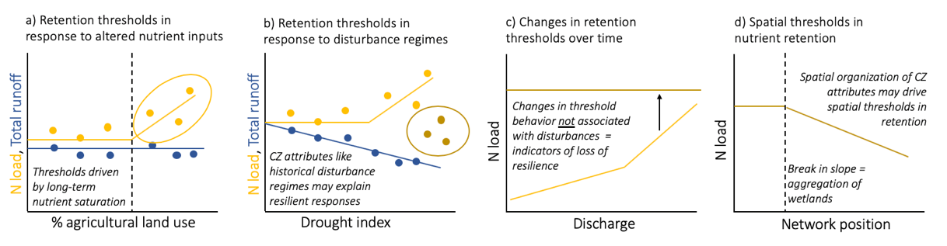

Fig. 11. Examples of threshold dynamics at continental/regional scales (a and b) and catchment scales (c and d) and their relationship to multidimensional resilience.  Dot symbols in panels a and b represent time-aggregated values for individual catchments. Associated regional-scale trend lines suggest a nutrient retention threshold in response to variable nutrient inputs (a) or differing response of catchments (either buffering or amplifying) to disturbance regimes (b).  At the catchment scale, high-resolution monitoring data can be examined for temporal (c) or spatial (d) changes in nutrient retention thresholds.

**Approach:** Available data sets for various constituents will be analyzed using traditional trend analyses (e.g., seasonal Mann-Kendall) and classified using exploratory data analyses (e.g. Budyko space (Budyko 1974)) or empirical C-Q models (Musolff et al. 2015; Underwood 2017). Complex-systems tools will be applied to extract patterns from time-series (e.g., concentration and discharge data). We will test the multidimensional resilience hypothesis that CZ attributes (catchment morphology and geology, vegetation type, dominant land ­cover, network structure/heterogeneity) may modulate/determine the nutrient use efficiency of a catchment and the relative importance of biological and physical retention mechanisms in both space and time. This type of hypothesis testing will help reveal the spatial and temporal resolution necessary to represent nutrient dynamics in various ecosystems and will provide empirical, multi-scale targets for Earth system models that incorporate lateral nutrient flux to river networks. More generally, this will provide a robust mechanistic framework to simulate present and future lateral and longitudinal carbon and nutrient flux across scales (Zarnetske et al. 2018). We have chosen simple but widely used methods, maximizing spatiotemporal coverage and logistical feasibility at the expense of detailed measurements at a few sites.

For sites with medium (e.g. weekly) or high-frequency (e.g. hourly) water chemistry data, we will conduct seasonal and event-scale concentration-discharge analysis. We will apply machine-learning tools, e.g. evolutionary algorithms and self-organizing maps to: *(1)* identify features (variables) important to unique hysteresis patterns, their relative strengths, and degree of cross-correlation, and feature interactions that may be epistatic and heterogeneous; *(2)* provide insight on the sources of variance; and *(3)* identify overall emergent trends in the distribution of hydrologic event classes over time in response to seasonal changes in vegetation and meteorology.

## From process to pattern: observations and modeling at focal sites

### Signals of changing precipitation composition and hydrological disturbances

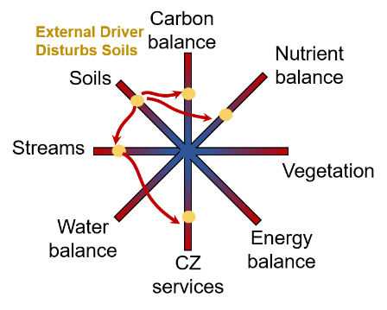**Rationale:** Acidification and recovery as well as overall heavy precipitation, punctuated by extreme hydrological disturbances, produce a great variety of CZ signals of carbon and nutrient retention vs. effluxes that are difficult to interpret. At the process level, our recent research has begun to link the recovery from acidification and subsequent changes in soil chemistry (ionic strength and pH) to changes in soil organic matter stability driving DOC loss at the catchment scale (Armfield et al. 2019; Cincotta et al. 2019). However, our lack of process understanding on combined carbon and nutrient retention capacity limits the ability to predict CZ resilience in this context. We therefore will expand our SRRW work and, using complex-systems analysis, select an additional watershed to perform process-based modeling on carbon and nutrient dynamics in the NE. For model parameterization, we will complement existing field instrumentation to collect soil moisture, soil gas composition, and soil chemistry data at higher resolution, and perform targeted experiments on soil leaching and gaseous exchange using, for example, soil cores.

Fig. 12. Effects of soil disturbance on CZ state and multi-dimensional resilience in the NE.

**Example hypotheses at the catchment scale in the NE:**

* We hypothesize that acidification and recovery differentially impact carbon and nutrient dynamics and lead to changes in C:N ratios and stoichiometry in soil and stream water data. DOC will be driven by changes in soil chemistry (i.e. effects of solubility colloidal interactions), while nutrients (corrected for atmospheric inputs) will be driven by biological dynamics (decreased productivity, plant nutrient uptake and microbial activity), overall decreasing exports during acidification and increasing them during recovery.
* We also hypothesize that CZ structure will modify the decoupled response of carbon and nutrients. Wetland locations and unbuffered soils will show highest retention of carbon and release of nitrogen and phosphate during acidification (low C:N ratio in solution) and relatively more carbon release during recovery (increasing C:N ratio in solutions).

**Approach:** Most long-term records to not include data on carbon and nutrient dynamics prior to acidification, hence we cannot determine baseline conditions before this prolonged disturbance. However, the process-based reactive transport modeling using BFP can simulate soil-DOC-nutrient interactions, including decomposition of organic matter that produces soil CO2 and DOC, and leaching of nutrients, as well as solute sorption on soil surfaces. We will include scenarios of variable solubility (e.g. lower for DOC and PO4 vs. nitrate) with changing precipitation composition (acid rain or not, input pH, SO4 content) and CZ subsurface composition (e.g., carbonate, clay content) to model concentration levels and C:N ratios in soil, groundwater, and stream water. CZ structure, including topography, land cover, wetland area, and soil mineralogy, will be spatially explicit. We will use field measurements and experimental data to calibrate the model to constrain reaction kinetics and sorption parameters that are indicative of the catchment storage capacity. The model outputs include water-related quantities such as spatiotemporal patterns of storage and fluxes, including snow packs, snow water equivalent, soil water (interflow), groundwater, and stream water. Biogeochemical output will include the temporal trend and spatial patterns of solutes, rates of biogeochemical transformation, and stored (sorbed) quantities. Additional sensitivity analyses will be run to disentangle the influence of individual drivers, one at a time, to offer mechanistic insights on their relative roles (Li 2019; Zhi et al. 2019). In addition, the simulation will be carried out at the decadal scale incorporating changing precipitation chemistry and climate to hindcast the past, forecast the future, and identify when and where transitions occur at what threshold.

The improved process-based understanding will be related back to patterns in stream water chemistry that may be tested at a broader scale using complex-systems tools described in section 3.1.

***Example hypotheses at the regional pattern scale:***

* Decoupling of carbon and nutrient dynamics will lead to a decrease in C:N ratios (1970-1990s) during acidification and an increase in C:N ratios during recovery (present day). Therefore, we expect to see clear thresholds in stream water C:N ratios before and after acid deposition recovery.
* Land cover and soil composition will moderate the response to changes in precipitation composition: catchments with high wetland coverage and unbuffered soils will show highest decoupling of C and N. Catchments with carbonate bedrock will buffer the effects of acidification more effectively, leading to less carbon retention during acidification and subsequently more stable C:N ratios over time.
* Lastly, we hypothesize that the combined effects of recovery and extreme hydrological events are most pronounced in areas with steep topography because the transport term is amplified.

### Signals of changing drought and fire disturbances

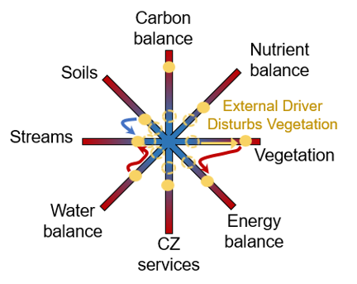**Rationale:** As winter snowfall turns to rain and snow retention declines, the role of snow in mediating water budgets, vegetation, and fire (and their interactions; Fig. 2) may change in profound ways. In the drought-affected SW, water availability is one of the most threatened CZ services. However, complex interactions (Fig. 13) and overlapping disturbances make predictions difficult. For example, the nature of eco-hydrological processes and feedbacks are highly nonlinear and interconnected (Fig. 2; (Tague et al. 2019)), hence detailed numerical models are needed in order to disentangle the likely mechanisms causing observed responses. We will combine long-term measurements, extensive field observations, and process-based modeling efforts to quantify the feedbacks between CZ structure and disturbance from fire and from changes to snow storage on catchment-scale water and carbon budgets (Fig. 2, 13). We will build on existing work in the two western locations that have been impacted by drought and fires. The ICB has long-term records and is uniquely suited to determine processes in this context, while the JRB has a shorter but detailed record of paired burned vs. unburned watersheds. In combination, these data will allow hypothesis testing across CZ structures and climatic gradients.

Fig. 13. Stabilizing (blue) and destabilizing (red) interacting to affect stream’s resilience due to fire. Open circles denote state prior to disturbance.

**Example hypotheses at the catchment scale in the SW:**

* Dense forests and shrub fields are more likely to experience stand-replacing fire and/or large-scale drought/disease mortality. These same types of areas are more likely to have increases in subsurface water storage following a vegetation disturbance (due to reduced transpiration and interception), which increases ecosystem resilience.
* Areas receiving greater precipitation occurring as snowfall and more north-facing aspects are likely to experience longer snowpack retention in response to disturbance thinning the canopy. Later snowmelt increases resilience by counteracting climate-induced changes to the hydrograph and reduces drought stress.
* If disturbance increases snowpack storage and soil moisture, this will increase the rate of regrowth (greater vegetation resilience). If disturbance causes erosion and reduced water infiltration (e.g., via fire-induced soil hydrophobicity), it will reduce the rate of regrowth (less resilience, and/or a state change). See Fig. 14.
* Areas where CZ structure (e.g. soil depth and texture) has little mediation of post-disturbance water availability will be more likely to shift from forest to shrub, forest to meadow, or shrub to meadow. Such state changes cause long-term increases in streamflow by decreasing transpiration and/or increasing snowpack retention.

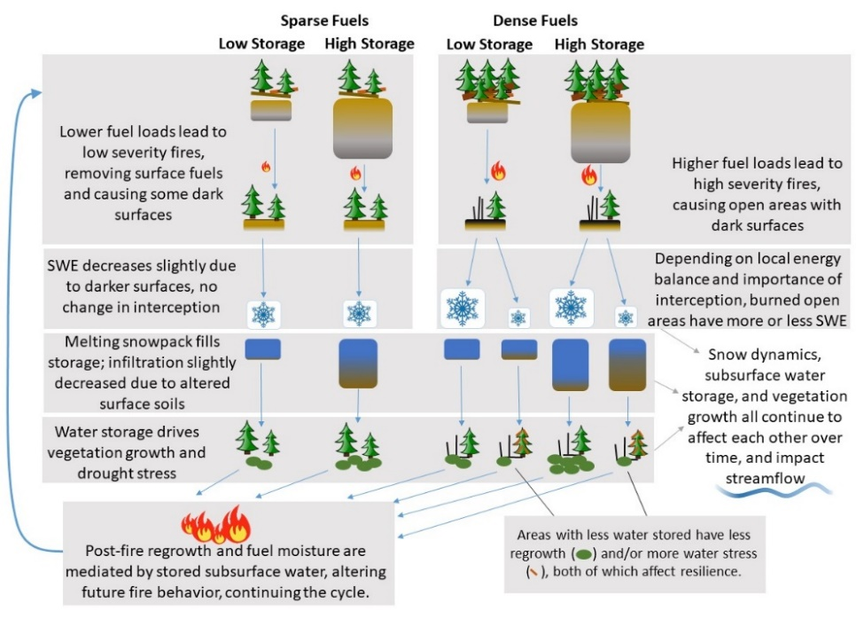

Fig. 14. Theoretical illustration of how CZ structure and disturbance (in this case, fire) can interact to produce different states of the CZ, and therefore its resilience in a snow-dominated catchment. Different combinations of forest structure and soil storage space can lead to different responses to fire in terms of soil moisture, snowpack, streamflow, and post-fire regrowth. These new post-fire states, in turn, will help determine the impact of future fires.

**Approach**: We will use a coordinated set of field observations and build connections to remotely-sensed indicators at the western sites (ICB and JRB). We will complement our datasets with key variables across gradients of CZ structure (i.e. soil observations). We will also use a combination of airborne and terrestrial laser scanning (lidar) to develop gradients in vegetation cover and vegetation type, as well as snow depth from existing snow-on flights in both basins. These data will be used to inform RHESSys and BFP to verify how different CZ structures might create various observable outcomes (conceptualized in Fig. 14).This improved process-based understanding on coupled effects of vegetation dynamics, drought and fire will be related back to patterns in stream water chemistry and remotely-sensed vegetation metrics. Our process hypotheses can then be tested at a broader scale using complex-systems tools (e.g., concept-drift detection) described in section 3.1.

## Operation and Maintenance of Instrumentation

We will maintain the physical infrastructure and collect comprehensive data on key environmental variables that govern CZ processes at our three focal sites as follows:

**SRRW:** To complement existing subsurface and instream instrumentation and allow for process-based modeling, we will install soil CO2 sensors in 5 key locations and 2 depths in the watershed as well as soil moisture and temperature sensors. We will purchase sensors and install these in collaboration with the USGS. We will also support the collection and analyses of major ions including nutrients, carbon species and pH from soil, stream water and ground water. These chemical and isotopic analyses are contracted out to the USFS in Minnesota and help determine water flow paths and soil- and groundwater chemical evolution in support of new measurements of soil gas concentration profiles.

**ICB:** Due to this site’s location within federally-designated wilderness, most long-term installations are not permitted at this catchment. However, we will assist with maintenance and calibration of a stream gage installed by Yosemite National Park in 2012 at the watershed outlet. We will also coordinate with the Park hydrologists to help maintain a weather and snow monitoring station located at Ostrander Lake. In addition, we will place temperature sensors and time lapse cameras throughout the watershed for a period of five years to track post-disturbance regrowth in an area burned by the Empire Fire in 2017 (such cameras have been in place since 2015, but there is currently no plan to maintain them past 2020) and for tracking snow depth across a gradient of elevations, aspects, canopy cover, and time since fire.

**JRB:** We will install turbidity sensors at two stream sites that will interface with existing streamflow-gaging instrumentation. We will provide partial support for field personnel to continue on-site instrument maintenance and data collection. In addition to sensor data, we will receive data on aqueous-phase analytical data from the University of Arizona, including DOC, nutrients (TDN, nitrate, phosphate) and pH for year round biweekly grab samples at the outlet of LaJara stream, weekly soil solution samples during the snowmelt period (mid-April to June) and monthly groundwater samples.

## Database Structure, Data Compatibility, and Coordination with the Network

The database will grow in size and complexity throughout the project through data mining, collection at field sites, and the results of process-based and complex-systems analyses. The database will include data on land-atmosphere interactions, vegetation and microbiota, the pedogenic and environmental dataset (PEDS), saprolite and bedrock as well as surface water, including USGS discharge networks, landsat remote sensors and ERA-5. As part of previous funding, we have already compiled a dataset, primarily comprising USGS stream chemistry datasets that correspond with the CAMELS (Catchment Attributes and Meteorology for Large-sample Studies) dataset (Addor 2017). The latter spans 493 forested headwater catchments from 1980 through 2010 and includes dissolved and particulate aqueous species, discharge, temperature and atmospheric deposition data. The participating site-specific data and metadata (Section 4) will be added for the testing of hypotheses at the regional and local scale. Further, we will build onto these efforts and add additional data from numerous sources (CZO, USGS, EPA, NEON, LTER) to allow for the integration and testing of hypotheses at the scale of the continental US. UVM already manages big data over time to examine complex socio-ecological research questions, such as the interactive effects of climate change and land use on the Lake Champlain Basin as part of EPSCoR funding (OIA 1556770).

**Data acquisition:** Given the scale of the project and the variety of datasets, the data acquisition approach will vary significantly depending on the setup of data sources – e.g., FTP, API, web scraping. Data generated in situ (e.g., from the four participating sites (Section 4)) will be saved to data files and transferred to our university server via secure FTP. Data from established public sources (e.g., CZO, USGS, EPA, NEON, LTER) will be extracted programmatically through their published APIs. When APIs are not available, a web scraper can be used. Chrome extension provides a promising tool for creation of a site map describing how the website should be traversed and which data to extract.

**Data integration:** Diverse datasets will need to be “normalized” with regard to the sampling frequency, amplitude, timeline, etc. of sensor signals to remove or reduce the ill effects caused by the heterogeneity of signal features. Despite most investigators having experience with these normalization tasks, significant challenges will exist given the heterogeneity of human-prescribed protocols for data format, metadata, and naming. That is, there is no centralized control or standard for the data repositories and, consequently, different sites may use different names, structures, and formats of data. We expect quite significant differences both across the disciplines (e.g., biology, geology, chemistry, hydrology, meteorology, ecology, forestry) and within each discipline (e.g., FNU in USGS NWIS and NTU among others for turbidity sensor measurements in hydrology). We will build our own metadata that comprise entity reconciliation mappings (e.g., methods surveyed by (Enríquez et al. 2017)) between heterogeneous names, structures and formats to facilitate finding semantically or structurally similar data. For pragmatic reasons, *selective mappings* will be performed to adequately cover those needed for the project scope that focus on the analysis of vulnerability (i.e., resilience and resistance) to changes of concern. If feasible, we will use a common data format (e.g., ASCII, CSV), one common structure metadata standard, and one common naming scheme – for integrating data acquired and data produced in the project. The specific data format and metadata standard will be determined at the project time in consultation with the HUB.

**Data storage**: Data acquired and integrated will be stored in a database housed in a university server, and integrated remotely into the HUB to share data (and models) with other thematic clusters in the collaborative network. Integration with the HUB will be “loose”, that is, through APIs (e.g., REST APIs, web APIs).

# Education and outreach plan: developing a diverse CZ and data science workforce

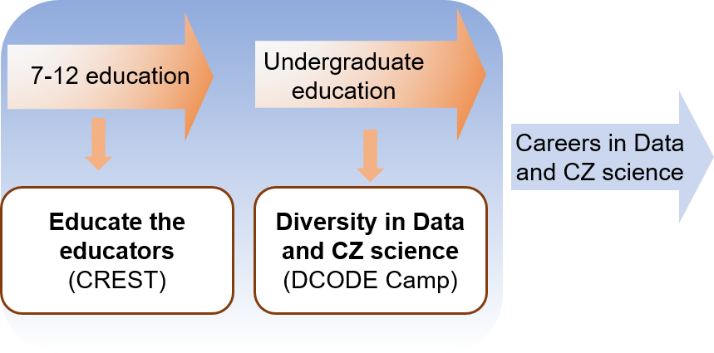Our education and outreach plan has the goal of **enhancing the growth of CZ and data science to fully include** **underrepresented groups in STEM**. We will recruit, educate and empower this diverse new generation of CZ and Data Science thinkers from middle and high school (7-12) to the undergraduate college level (Fig. 15). Each of these levels has their own opportunities for development and challenges for implementation that we address with targeted approaches. Throughout development, implementation, and assessment we welcome collaborators from other thematic network clusters and the broader community to grow diversity in CZ and data science across the US.

Fig. 15. Education and outreach at multiple levels to enhance the growth of CZ and data science.

## Educating the educators

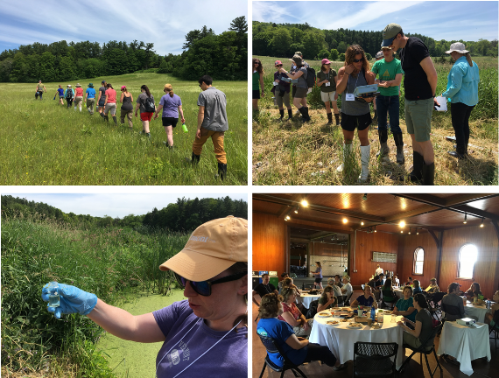**Rationale:** We will build upon a successful 6-year STEM professional development program led by co-PI Toolin (Champlain Research Experience for Secondary Teachers = CREST). This program is designed to enhance the knowledge, practices, and skills of grade 7-12 teachers in high-need schools by engaging in authentic STEM research about the Lake Champlain Basin and best practices of STEM teaching and curriculum development (Fig. 16). The need for this program is evident in the low achievement scores in math and science across historically marginalized economic, racial or disability groupings in high-need schools (NECAP 2017; SBAC 2017).

The CREST program is conducted each year in late June for grade 7-12 teachers at various research sites in VT and engages teachers in field-based scientific research alongside scientists and STEM curriculum development with teacher educators. A follow-up research project conducted during the academic year by program staff examines the impact of the CREST program on teacher practice with a particular focus on place-based and project-based principles and practices (Tal et al. 2006; Toolin & Watson 2010). Toolin, Rizzo and Perdrial already successfully integrated CZ concepts into the CREST curricular framework; we now will build on this program and complement the offering with a CZ and data science immersion program during the academic year.

Fig. 16. Teachers experience field based approaches, learn how to use water quality test kits, perform analyses and reflect on their experiences.

**Approach:** The CZ and data science immersion will include 1) teacher participation in monthly online webinars, 2) classroom observations by project staff with onsite mentoring, and 3) the implementation of an action research project that will measure the impact and effectiveness of CZ projects in the classroom (Brkich & Shumbera 2010; Toolin & Watson 2010). We will recruit a subset of CREST participants from VT in year 1 and 2 and make iterative improvements in subsequent years based on regular feedback from program participants, staff, and evaluators.

|  |  |  |  |  |  |
| --- | --- | --- | --- | --- | --- |
| ***CZ-CREST week*** | | | | | |
|  | ***Monday*** | ***Tuesday*** | ***Wednesday*** | ***Thursday*** | ***Friday*** |
| ***AM*** | Introduction to the CZ. Rotating investigations. Constructed Wetlands. Water quality monitoring. | Lake Champlain geology, lake Champlain sensor data collection and analysis | How are conceptual models central to science and science teaching? Data analysis and representation. | Fluvial ecosystems, water quality and benthic invertebrates. | Finalizing CZ Curriculum Projects.  Final Project Roundtables |
| ***PM*** | Rotating field investigations.  Reflection/Wrap-up/CZ and data science Curriculum Development | | Project sharing and ongoing development  Reflection/Wrap-up | Applying CS and Data science to 7-12 STEM Teaching | Surveys, evaluations, and program closing. |
| **Lead** | Toolin, CREST Staff, Perdrial, Rizzo, Underwood. | | | | |

**Who**: Perdrial will lead the CZ professional learning and research experiences for teachers and Rizzo will lead the development of the data science programming to support and educate participating teachers. Underwood will participate in selected programming on data science. Toolin will oversee the CZ-CREST integration and all assessment. A part-time outreach coordinator will be hired to coordinate classroom visits in VT.

## **Diversity in undergraduate education:** DCODE (Diversity in Critical Zone Outdoor and Data Science Education) Camp

**Rationale:** The lack of diversity in Earth science limits education and career opportunities for underrepresented groups and excludes creative ideas and perspectives necessary for transformative science. In collaboration with historically black colleges and universities (HBCU), we will therefore develop and implement an undergraduate outdoor education program that combines CZ and data science and will enhance the participation of underrepresented groups. During this one-week summer camp, 15 undergraduate students, of which at least half will be recruited from HBCU, will receive hands on training in field based research and data science in VT. Our science training will be embedded in a curriculum that emphasizes the connection between diversity, place and history using story and dialogue-based pedagogy. **The overarching goal of the program is to develop equitable and transformative exchange between institutions, instructors and participants** as template that can be adapted by the broader CZ community to broaden participation and inclusion across the US. Towards this goal we will collaborate with HBCU faculty for planning, design and implementation of the programming. **The specific goals of DCODE camp** are 1) apply the knowledge of CZ structure to develop hypotheses and collect field data for hypothesis testing, 2) apply data science to generate and interpret plots on sensor data, and 3) critically reflect how identity, history and place shape diverse experience in STEM and 4) demonstrate teamwork and collaboration skills in a diverse team.

**Approach:** inclusion and diversity will be central to this education program and faculty from HBCU will be included in all phases of the camp design, implementation and assessment. Because we have existing collaborations with Jackson State University, MS (JSU), we will collaborate with JSU faculty in year 1 and 2 and will broaden our recruitment to more minority serving institutions thereafter. Camp design will begin with a 2-day meeting with all participating instructors at JSU. During this meeting, we will model important aspects of the camp experience including facilitated conversations about identities, differences, and historical trauma. Building on this basis, we will begin development of CZ and data science programming for the DCODE on site, and continue with monthly online meetings. The DCODE camp content will include 1) hands-on field experiences in CZ science, 2) use of sensors for data collection, and 3) programming and 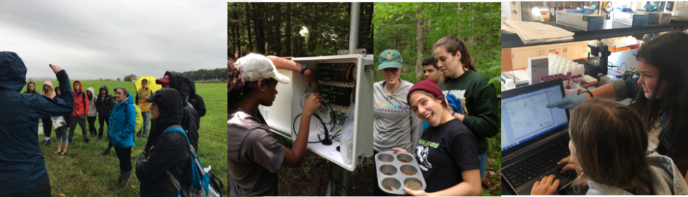analyses (see example schedule).

Fig. 17. Undergraduate students learn field-based sample collection and data analysis for CZ science.

We illustrate possible ways of integration of CZ and data science in a diverse and inclusive setting on the example of sensors. For this, students will critically reflect on the use of high-frequency sensors and will learn to measure environmental parameters through a combination of hands-on classroom and field activities and guided discussions. To become familiar with optical and infra-red sensors and to learn how to program data loggers, students will first use sensors in the lab setting to collect and analyze environmental data (e.g. CO2 concentration). Also in the lab setting, teams of students will apply their knowledge on sensors to develop a plan for sensor placement in the field to collect CZ data. In the field, students will be guided to assess the feasibility of the placement plan and if necessary revise based on, e.g., scientific, economic or access considerations. Guided dialogue in the field will contrast the concept of “sensing” the environment with technology with our intuitive sense of place. During the follow-on data science sessions students will analyze data and integrate findings to inform CZ process understanding. This session will be accompanied with discussions around ethical issues of data collection including power and privilege considerations of data ownership and use.

|  |  |  |  |  |  |  |  |
| --- | --- | --- | --- | --- | --- | --- | --- |
| ***Example schedule of DCODE camp*** | | | | | | | |
|  | ***Sunday*** | ***Monday*** | ***Tuesday*** | ***Wednesday*** | ***Thursday*** | ***Friday*** | ***Saturday*** |
| ***AM*** | Arrival throughout the day | Introduction to the CZ concept | Working with sensors: soils and streams | Conceptual models and data science | data science and programming | Working with your data | Departure |
| ***PM*** | Icebreaker and facilitated reflection and discussion | Field work: the CZ and place based learning | Working with sensors: soils and streams | Ethics of data science | data science and programming | Final reflections surveys, program end |  |
| **Evening** |  | Reflection on the day and assessment | | | | |  |
| **Lead Facilitator** | Outreach and diversity staff, Perdrial, Rizzo | Perdrial, JSU faculty and staff | Seybold JSU faculty and staff | Rizzo and guest speaker | JSU faculty and staff | All faculty and staff | Outreach staff, Perdrial |

**Who:** Perdrial and Rizzo, supported by our outreach coordinator, will proactively recruit participating faculty and students. Perdrial, Seybold and Rizzo will lead the development and implementation of programming around the CZ, sensors and data science. Collaborator Blouin (letter provided) will complement the program with place based pedagogy. To support the growth of authentic, equitable and enduring relationships between institutions, instructors and students and to guide and facilitate work around themes of power, privilege and race we will partner with a center for leadership in diversity (letter provided), that will accompany all phases of DCODE camp.

**Assessment:** Toolin will lead the appropriate formative and summative assessment of effectiveness of both CREST and DCODE camp that will be aligned with program goals and help adapt and modify our approach based on the outcomes. For CREST the CZ curriculum project will serve as the primary summative assessment that demonstrates the degree that teachers understand and apply the knowledge of CZ and data science into their curriculum practice. Classroom observations will measure the extent to which teachers implement CZ and data science curriculum projects during the academic year. DCODE camp summative assessments will measure the extent to which students understand, apply, and synthesize the knowledge of CZ concept in hypotheses development and testing and the application of data science tools in generating and interpreting data plots. In addition, formative assessments such as daily journal reflections and surveys will measure participants’ ability to work collaboratively in teams and to critically reflect on how identity, history and place shape diverse experience in STEM as it relates to their professional experiences in DCODE Camp. For both activities we will develop rubrics matched to these performance criteria to measure achievement and progress in this regard.

# Dissemination: how we will manage, maintain and disseminate data and results from the network operation and scientific investigations

1. Our team will disseminate results of all research activities in the form of webinars (see below), conference presentations, peer-reviewed publications, press releases, and executive briefs (for policy-relevant products). Our team includes five early career scientists and we will involve three postdoctoral researchers, five graduate students and several undergraduate researchers across four states all of which will be mentored by senior personnel to submit proposals to Federal, state and private sources/foundations.
2. The CREST and DCODE programs will develop and conduct professional learning opportunities (summer research experiences) for instructors across several states. Through CREST we will reach up to 80 middle and high school students through our “educate the educators” program each year. Because CREST project-learning plans will be made available to any number of other 7-12 teachers this number will be ever growing. With DCODE camp we will reach 15 undergraduate students annually and envision this experience to ultimately serve as a template for more programming of this type.
3. We are committed to the partnership with the HUB where we will assist in developing and documenting common data formats, structure metadata standards, naming schemes, etc. for integrating data/information produced in this project.

**Assessment:** Following the American Geophysical Union *Voices for Science* model, we will report individual and institutional activities as a part of each project meeting. By keeping ourselves accountable and discussing these goals throughout the project, rather than just when annual or final report are due, we will stay better coordinated and focused on the public-facing portion of this project. In this time of division and widespread misunderstanding of the role of science in society (Ditto et al. 2018), we view these outreach activities as equally important to the traditional research components. By discussing and analyzing our varied experiences with outreach and activism (see biosketches), we will cross-pollinate best practices and cultivate transdisciplinary perspectives and interests in the students and early career researchers on the project.

# Engagement Plan

**We will facilitate the** use of our cluster infrastructure by other research teams and **engage the community in research and education by i) proactively recruiting new members and supporting additional research applications, iii) supporting travel to our all hands meeting and education activity and iv) providing training and access to data science.**

1. **We will proactively recruit new members and supporting additional research applications: a survey led by Perdrial and Harpold (2014) indicated that scientists and educators outside the CZ network are hesitant to engage with the community, suggesting that outside participants need to be proactively recruited. We therefore will employ a part-time outreach coordinator who will promote participation via social media and networking activities, and who will also actively recruit new participants. We will actively promote the inclusion of more PhD and post-doctoral researches by supporting research applications to, for example, the GUND institute at UVM. We will also invite outside participants to participate at DCODE camp development and to bring similar programming to other places in the US.**
2. **We will support travel to our all hands meeting (see management plan) and education activity by offering travel stipends for up to 10 participants per year beginning in year two.**
3. **We will actively train other researchers how to utilize this important community resource by offering workshops and a webinar series in collaboration with the Research Coordination Network (RCN) led by Kamini Singha (letter provided). One of the goals of this RCN is to train scientists in multidisciplinary data collection and modeling, with special emphasis on recruiting and training individuals from underrepresented groups. We also will intentionally design our database in a way that makes it accessible to the larger community for hypothesis testing.**

# Results from previous NSF support

**PIs Perdrial, Harpold, Underwood, Rizzo and collaborator Li** have received funding from NSF-GG (2018-2021), $300,204 on “Collaborative Research: Combining Complex Systems Tools, Process-Based Modelling and Experiments to Bridge Scales in Low Temperature Geochemistry” where a multiscale approach combines i) statistical modeling on big data from across the US (USGS and CZO’s); ii) process-based (reactive transport) modeling for several watersheds; and iii) selected experiments on soils to test hypotheses on the release of carbon into streams. **IM:** this project provides a template for the integration of scales, disciplines and approaches in low temperature geochemistry. The combination of big data, statistical and process-based modeling with experiments to bridge scales varying >10 orders of magnitude is novel and transformative for the field of low temperature geochemistry. **BI**: we collaborate with Toolin to integrate the CZ concept into a highly successful program for secondary teacher education to teach in accordance with the Next Generation Science Standards (NGSS). We have not yet completed the second year of the project, however our efforts have already resulted in several conference presentations (>15), publications, and a workshop (Armfield et al. 2019; Cincotta et al. 2019; Sterle et al. near submission; Underwood et al. 2019; Wen et al. 2019), references are highlighted in the reference list.

**Co-PI Abbott** was recently awarded funding for an Arctic System Science project (Award 1916565- Collaborative Research: Arctic Stream Networks as Nutrient Sensors in Permafrost Ecosystems), which began on October 1st of 2019. **IM:** This project investigates how permafrost thaw affects carbon and nutrient flux and form in Arctic river networks. It uses an empirical, multi-scale approach to generate targets for Earth system models with lateral and longitudinal nutrient flux, reducing one of the largest sources of uncertainty in predicting the permafrost climate feedback. **BI:** The project promotes ecological literacy and engagement by creating a broader impacts network, including partnership with a Contemporary Dance Company and Ecotopia Now!, bringing Arctic and climate science directly to ~30,000 high school students. So far the project has generated 3 presentations and 1 publication (Shogren et al. 2019).

**Co-PI Toolin** has received funding through the NSF Robert Noyce Scholarship Program (DUE: 1540802, Toolin, PI, Waterman, Smith, Tang, Co-PIs, $799,882, 10/15-9/20) **IM and BI**: the program is designed to attract, prepare and retain secondary school teachers in the natural and environmental sciences and mathematics licensure to teach in high need schools in the US.

**Co-PI Lee, Boisrame and Seybold** have not received NSF funding in the past 5 years.

# Broader Impact

**We will provide interdisciplinary training for a new and diverse workforce in STEM:** multiple graduate and undergraduate students will receive training in complex-systems tools and the use of multiple approaches (ranging from field and lab experiments to modeling). Our “educate the educator” approach with CREST will reach hundreds of 7-12 grade students and provide training in CZ and data science to inspire the new generation of critical thinkers.

**We will provide templates for education**: our DCODE camp is intentionally designed to build equitable and transformative partnerships with HBUCs to truly enhance diversity in Earth science on a long-term. To broaden participation further, we have included travel support for participants from the CZ network and the broader community to join, learn and build upon our approaches to continue and grow more programming across the US.

**We also provide data and tools for science across scale:**  Our data base will be open to the broader community and will contain data that go far beyond the scope of our cluster and can be applied to generate and test more hypotheses on, for example, weathering patterns or contaminant dynamics and so forth. We will employ a combination webinars, presentations, travel support for bringing new participants to all hands meetings, and other outreach, in order to teach others to use these data to transcend the uniqueness of a single site and to be able to address regional and global problems with complex-systems tools.